TASK NOTES

GOAL
- Design a feature so that a popup appears when the user creates a new task to allow other specifications like date, time, and notes

TASK NOTES FUNCTION
- We will have to add this function above our add_task( ) function because we're going to reference this function within add_task( )
- We'll define a function add_task_notes( )
- We'll initialize a Toplevel widget
  - Give it a title
  - Set geometry
  - .transient(parent_window) so the popup stays connected with the root window
  - .grab_set( ) so the user can't click the main window until the Toplevel popup closes
  - .focus_set( ) so the user can start typing in our entry labels

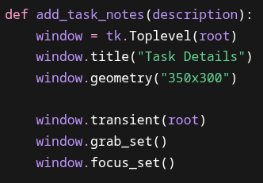

TOPLEVEL ENTRIES
- We'll append this to our add_task_notes( ) function
  - We want the user to specify date, time, and have a notes section
  - We'll have a Label widget to specify the date Entry widget on the same row
  - We'll have a Label widget to specify the time Entry widget on the same row
  - We'll have a Label widget to specify the notes Text widget above the Textbox widget
  - We'll use .grid( ) for placing everything because of our row / column layout
  - We'll also add 10pixels of horizontal padding between each Label and Entry widget and 8pixels of vertical padding between each row
  - The date Label and Entry widgets will be placed on row=0 and column=0 & 1
  - The time Label and Entry widgets will be placed on row=1 and column=0 & 1
  - The notes Label widget will be placed on row=2 and column=0
  - The notes Text widget will be placed on row=2, and column=1

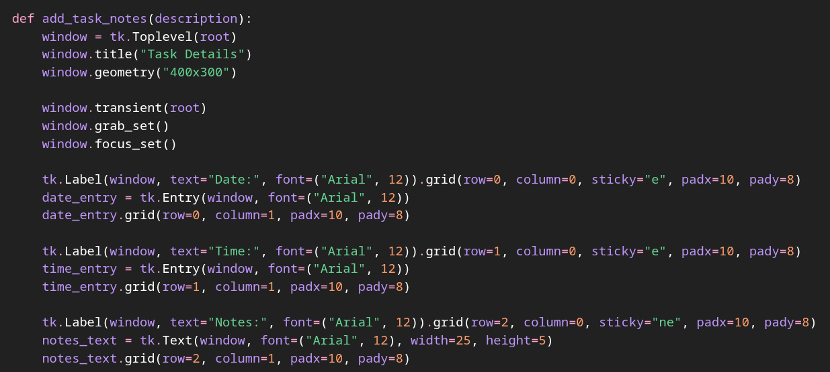

ADDING A SCROLLBAR TO TEXT WIDGET
- Sometimes a user's notes may exceed past the designated space for a Text widget
- A scrollbar is a good indicator to let the user know that there is more information that can't be seen
- We'll change our above code to insert a frame where our Text widget is
- We'll place our Text widget inside that frame and pack it left, with fill='both' and expand=True
- Then we'll add our Scrollbar widget, pack it right, with fill='y'
- We'll be sure to add all the correct functionality configurations and commands with our Scrollbar

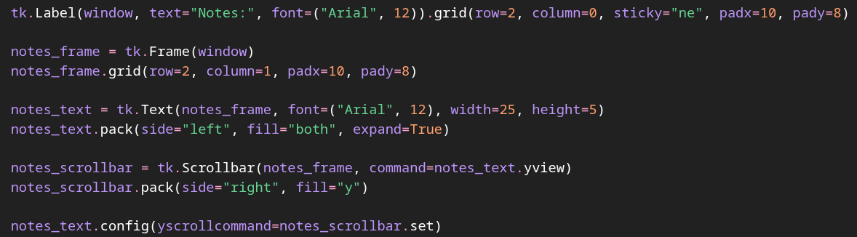

SAVING TASK NOTES
- We'll create a nested submit( ) function within our add_task_notes( ) function because we'll need access to all of the data that the user inputs
  - NOTE that nested functions have access to variables within their parent function
- Within submit( ) we'll define task as a dictionary that takes all of our new values
- We'll append the task to our global tasks list
- We'll insert the newly created task description into our Listbox widget with .insert(tk.END, description)
- We'll save our tasks
- We'll delete the main window's Entry widget with task_entry.delete(0, tk.END)
- We'll close the popup with window.destroy( )

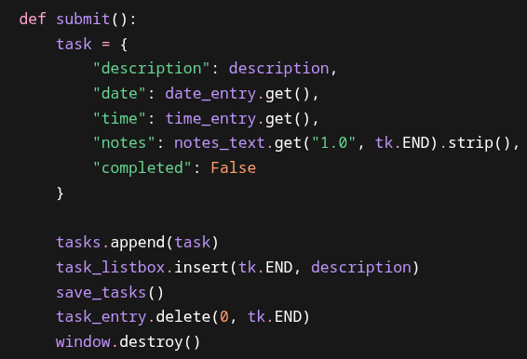

SUBMIT BUTTON
- We'll add a submit button for the user – that can also be submitted by pressing 'enter', that saves their task notes
- When we use .grid( ), we'll use columnspan=1 to center our button because visually, most of the space is in column=1
- Then we'll bind our entire popup window to run submit( ) when we press 'enter'
  - We'll need to add event=None as a paramter to our submit function

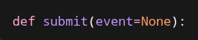

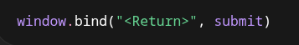

FULL TASK CODE

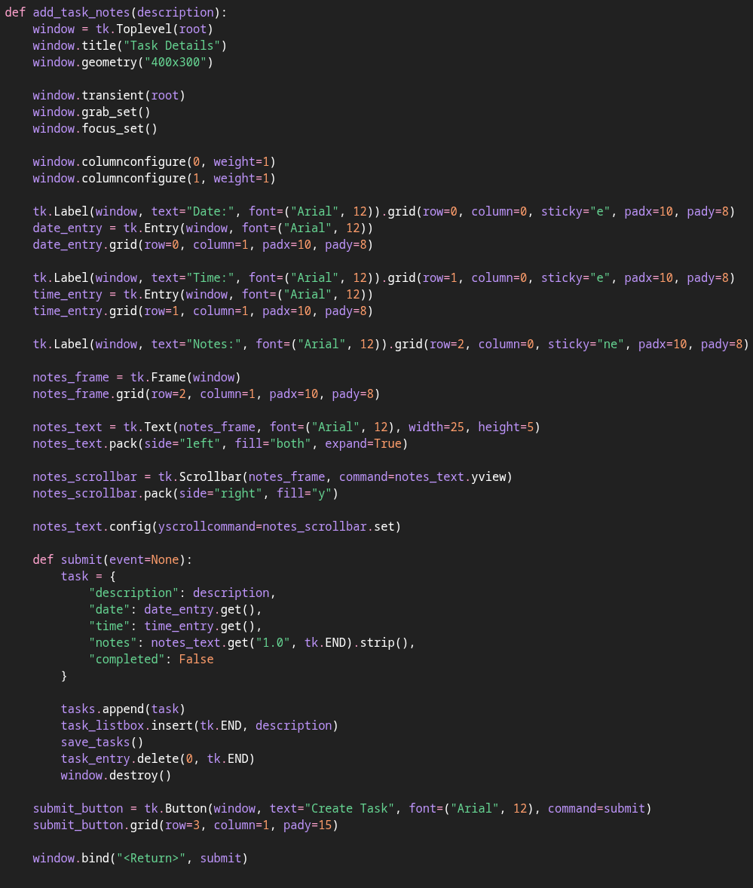

FULL CODE
import tkinter as tk
import json
from tkinter import simpledialog
root = tk.Tk()
root.title("Task List")
root.geometry("500x450")
tasks = []
completed_tasks = 0
drag_start_index = None
def add_task_notes(description):
window = tk.Toplevel(root)
window.title("Task Details")
window.geometry("400x320")
window.transient(root)
window.grab_set()
window.focus_set()
tk.Label(window, text="Date:", font=("Arial", 12)).grid(row=0, column=0, sticky="e", padx=10, pady=8)
date_entry = tk.Entry(window, font=("Arial", 12))
date_entry.grid(row=0, column=1, padx=10, pady=8)
tk.Label(window, text="Time:", font=("Arial", 12)).grid(row=1, column=0, sticky="e", padx=10, pady=8)
time_entry = tk.Entry(window, font=("Arial", 12))
time_entry.grid(row=1, column=1, padx=10, pady=8)
tk.Label(window, text="Notes:", font=("Arial", 12)).grid(row=2, column=0, sticky="ne", padx=10, pady=8)
notes_frame = tk.Frame(window)
notes_frame.grid(row=2, column=1, padx=10, pady=8)
notes_text = tk.Text(notes_frame, font=("Arial", 12), width=25, height=5)
notes_text.pack(side="left", fill="both", expand=True)
notes_scrollbar = tk.Scrollbar(notes_frame, command=notes_text.yview)
notes_scrollbar.pack(side="right", fill="y")
notes_text.config(yscrollcommand=notes_scrollbar.set)
def submit(event=None):
task = {
"description": description,
"date": date_entry.get(),
"time": time_entry.get(),
"notes": notes_text.get("1.0", tk.END).strip(),
"completed": False
}
tasks.append(task)
task_listbox.insert(tk.END, description)
save_tasks()
task_entry.delete(0, tk.END)
window.destroy()
submit_button = tk.Button(window, text="Create Task", font=("Arial", 12), command=submit)
submit_button.grid(row=3, column=1, pady=15)
window.bind("<Return>", submit)
def add_task(event=None):
description = task_entry.get()
if description == "":
return
add_task_notes(description)
def delete_task():
selected = task_listbox.curselection()
if selected == ():
return
index = selected[0]
task_listbox.delete(index)
tasks.pop(index)
save_tasks()
def drag_task(event):
global drag_start_index
new_index = task_listbox.nearest(event.y)
if drag_start_index is None:
return
if new_index == drag_start_index:
return
task = tasks.pop(drag_start_index)
tasks.insert(new_index, task)
refresh_listbox()
task_listbox.selection_set(new_index)
drag_start_index = new_index
def load_tasks():
global tasks
global completed_tasks
try:
with open("tasks.json", "r") as file:
data = json.load(file)
tasks = data["tasks"]
completed_tasks = data["completed_tasks"]
for task in tasks:
task_listbox.insert(tk.END, task["description"])
except FileNotFoundError:
tasks = []
completed_tasks = 0
def mark_completed():
global completed_tasks
selected = task_listbox.curselection()
if selected == ():
return
index = selected[0]
task_listbox.delete(index)
tasks.pop(index)
completed_tasks += 1
save_tasks()
update_counter()
def refresh_listbox():
task_listbox.delete(0, tk.END)
for task in tasks:
task_listbox.insert(tk.END, task["description"])
def save_tasks():
data = {
"completed_tasks": completed_tasks,
"tasks": tasks
}
with open("tasks.json", "w") as file:
json.dump(data, file)
def start_drag(event):
global drag_start_index
drag_start_index = task_listbox.nearest(event.y)
def stop_drag(event):
save_tasks()
def update_counter():
counter_label.config(text=f"Tasks Completed: {completed_tasks}")
def update_counter_manual():
global completed_tasks
new_total = simpledialog.askinteger(
"Update Completed Tasks",
"Enter the number you want the running total to be:",
parent=root
)
if new_total is None:
return
completed_tasks = new_total
save_tasks()
update_counter()
task_listbox = tk.Listbox(root, font=("Arial", 14), width=40, height=10)
task_listbox.pack(pady=10)
task_listbox.bind("<Button-1>", start_drag)
task_listbox.bind("<B1-Motion>", drag_task)
task_listbox.bind("<ButtonRelease-1>", stop_drag)
load_tasks()
task_entry = tk.Entry(root, font=("Arial", 14))
task_entry.bind("<Return>", add_task)
task_entry.pack(pady=10)
button_frame = tk.Frame(root)
button_frame.pack(pady=5, fill="x", padx=40)
delete_button = tk.Button(button_frame, text="Delete Task", font=("Arial", 12), command=delete_task)
delete_button.pack(side="left", padx=5)
add_button = tk.Button(button_frame, text="Add Task", font=("Arial", 12), command=add_task)
add_button.pack(side="left", padx=5)
mark_button = tk.Button(button_frame, text="Mark Completed", font=("Arial", 12), command=mark_completed)
mark_button.pack(side="left", padx=10)
counter_frame = tk.Frame(root)
counter_frame.pack(pady=10)
counter_label = tk.Label(counter_frame, text=f"Tasks Completed: {completed_tasks}", font=("Arial", 14))
counter_label.pack(side="left", padx=5)
update_counter_button = tk.Button(counter_frame, text="Update", font=("Arial", 12), command=update_counter_manual)
update_counter_button.pack(side="left", padx=5)
root.mainloop()

